Neuk Perspectives Visual Story

Welcome to Neuk Perspectives! This visual story will help you get ready for a visit to the exhibition.

Part 1: Getting to Neuk Perspectives

The exhibition is at WASPS Patriothall Gallery, Patriothall, Edinburgh EH3 5AY
Google map link
(Please note that though google maps correctly shows the lane called Patriothall, it puts the map marker for Patriothall Gallery in the wrong place. Please see the map on the next page for an accurate picture of where Patriothall Gallery is).
Patriothall Gallery is in Patriothall, which is a small lane off Hamilton Place in Stockbridge. It is almost directly opposite Stockbridge Library.
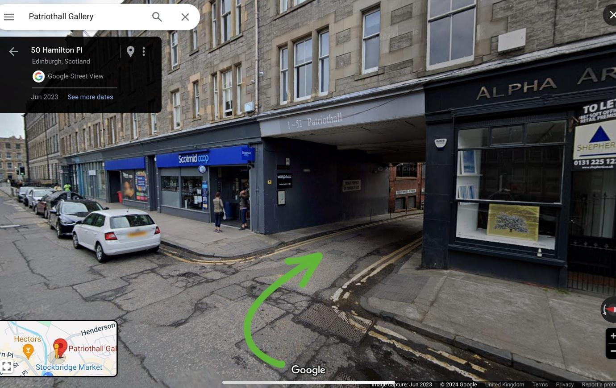
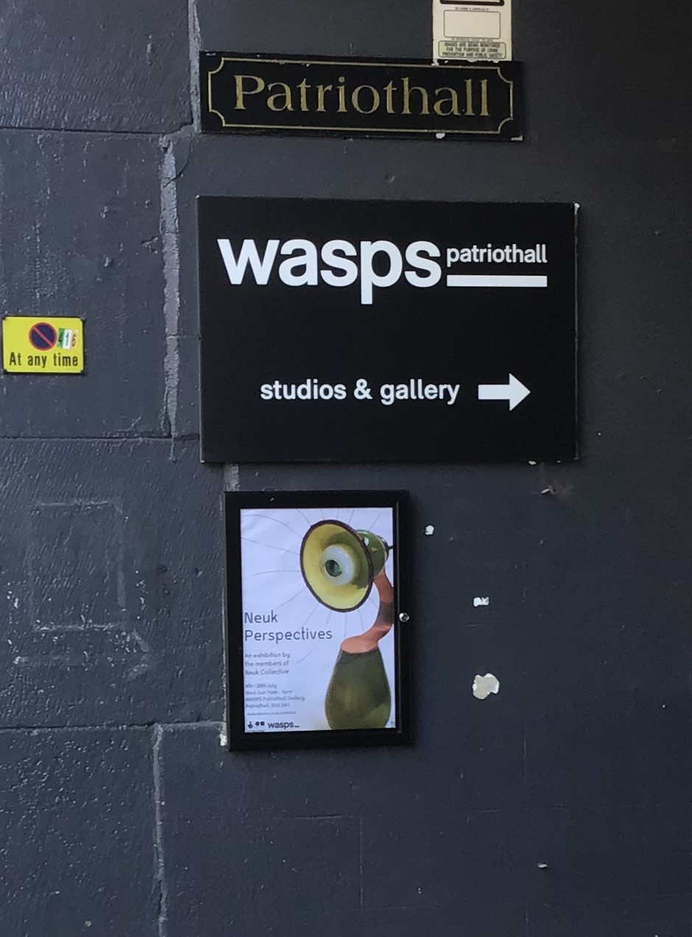

There is a sign for WASPS studios on each side of the lane:

The lane goes round in a horseshoe shape to reach WASPS Patriothall Gallery:
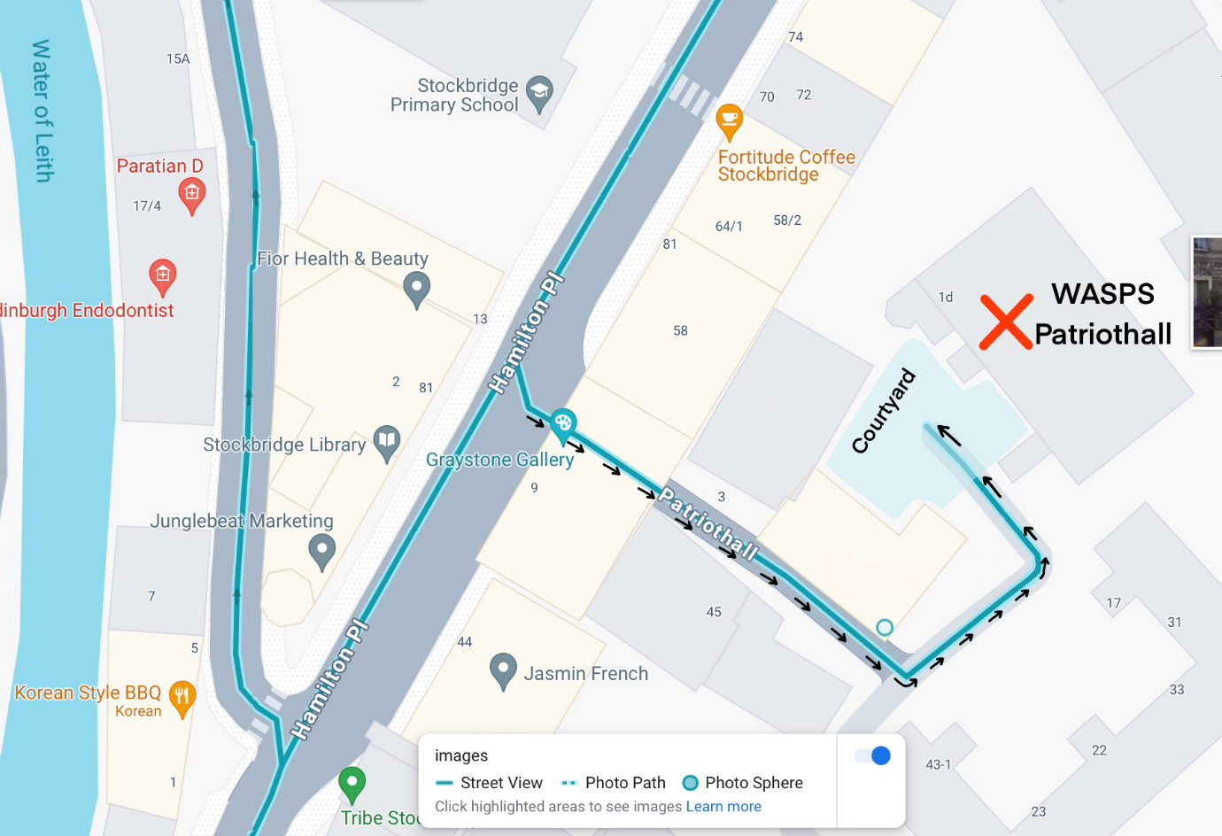

From Hamilton Place, go down Patriothall lane, and turn left at the bottom, then left again into a courtyard. You have reached Patriothall Gallery!
Photos of the journey:

Going down Patriothall from Hamilton Place:
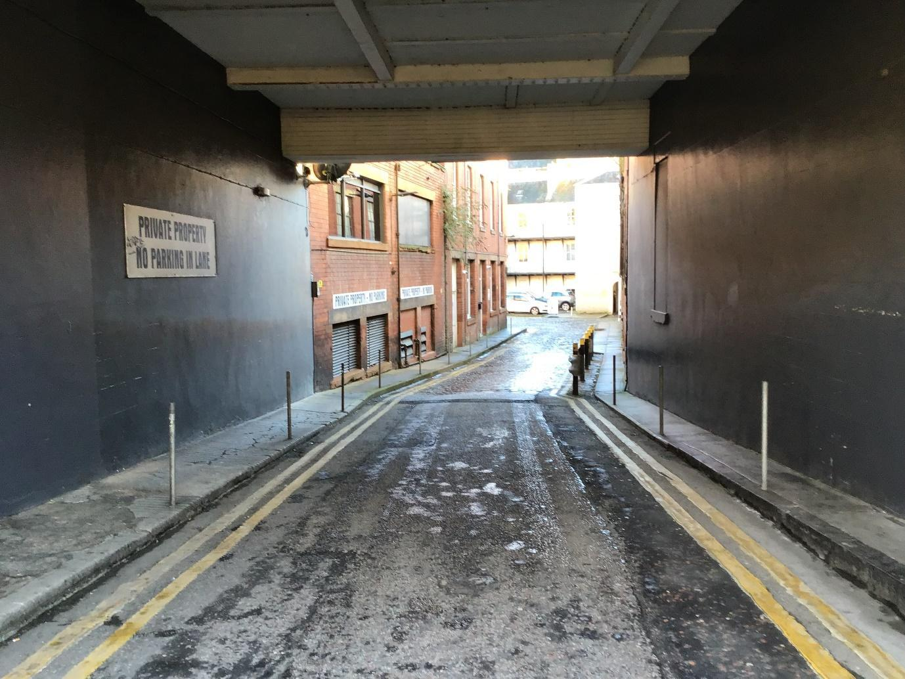

Turning left at the bottom of the lane
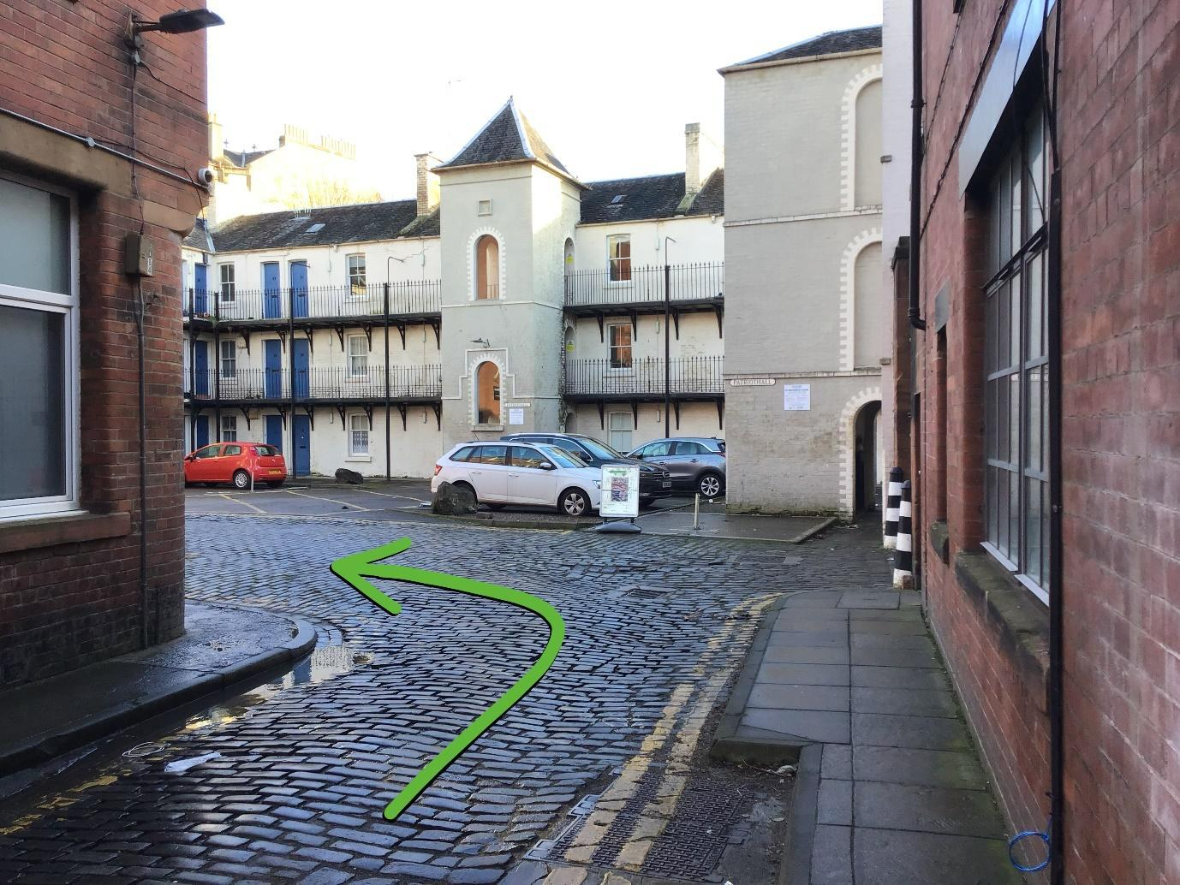
Turning left again: 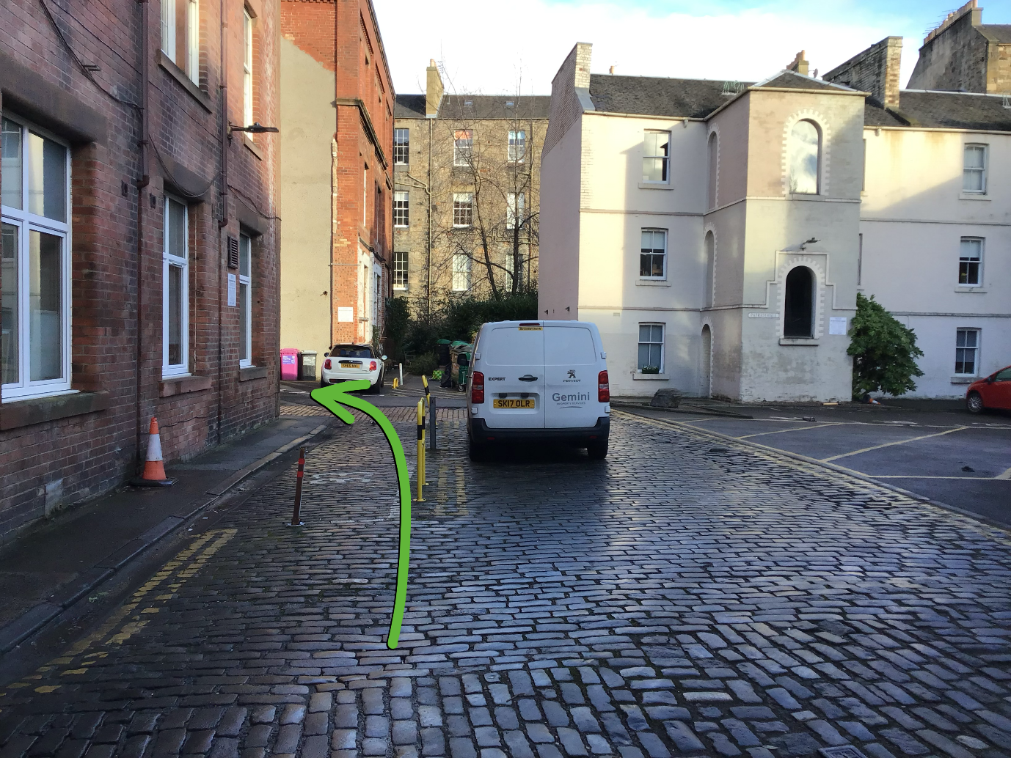
The gallery is in the red brick building:
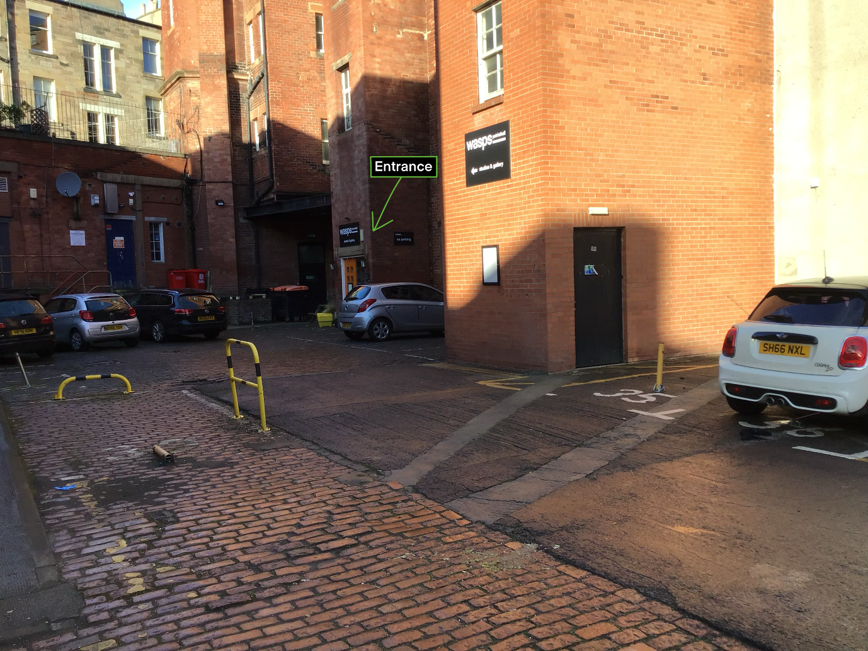
The gallery entrance:
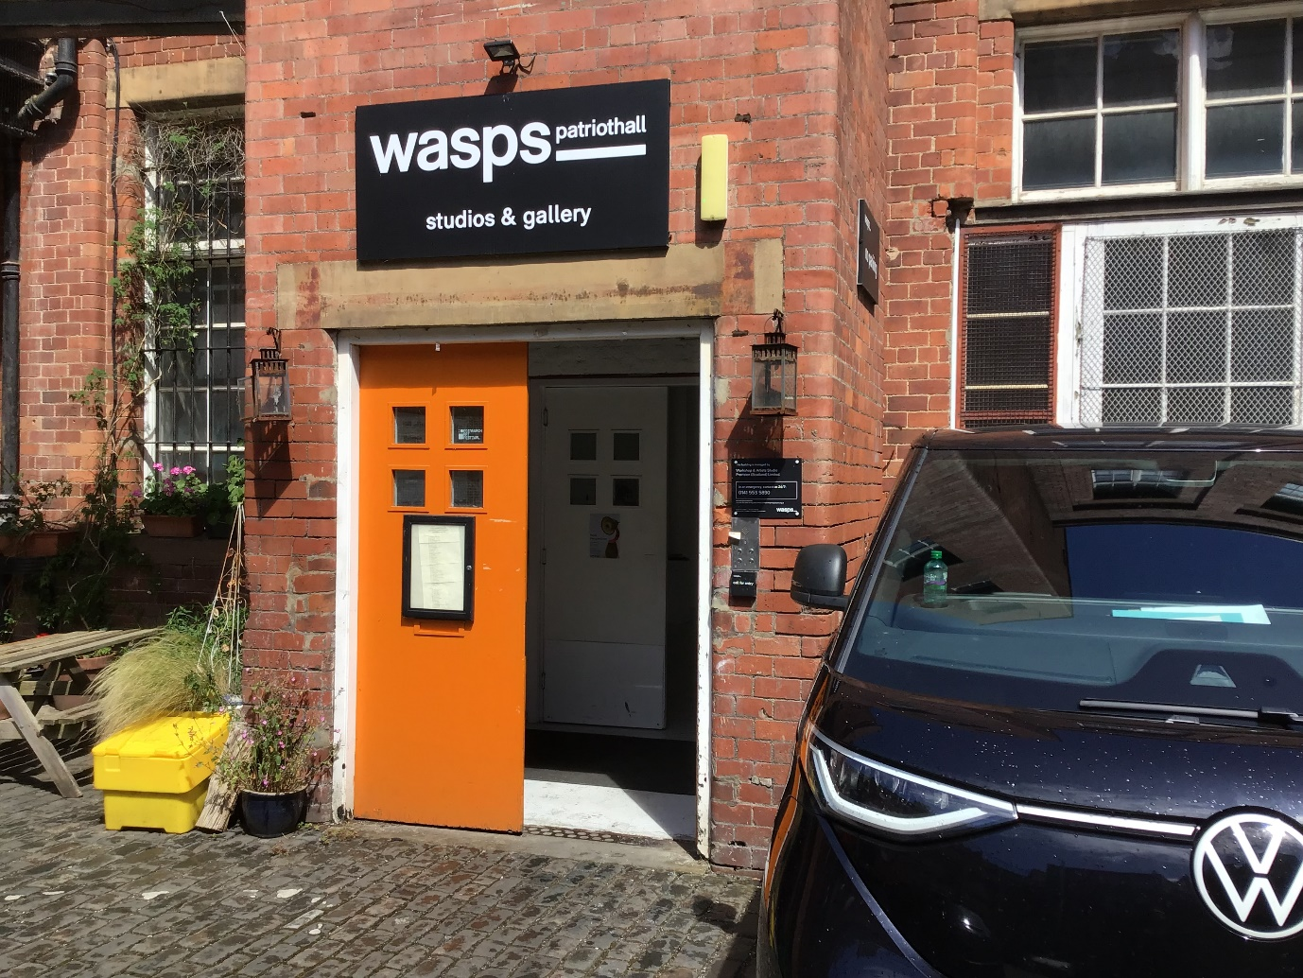

There is no parking but Stockbridge has convenient public transport:
The 24 and 29 buses go to Raeburn Place (5 minute walk)
The 36 bus goes to Hamilton Place (3 minute walk)
The 27 and 23 go to the bottom of Dundas Street (an 8 minute walk along Henderson Row).

Part 2: What’s in the Neuk Perspectives Exhibition

Inside the exhibition you will see lots of different artworks.
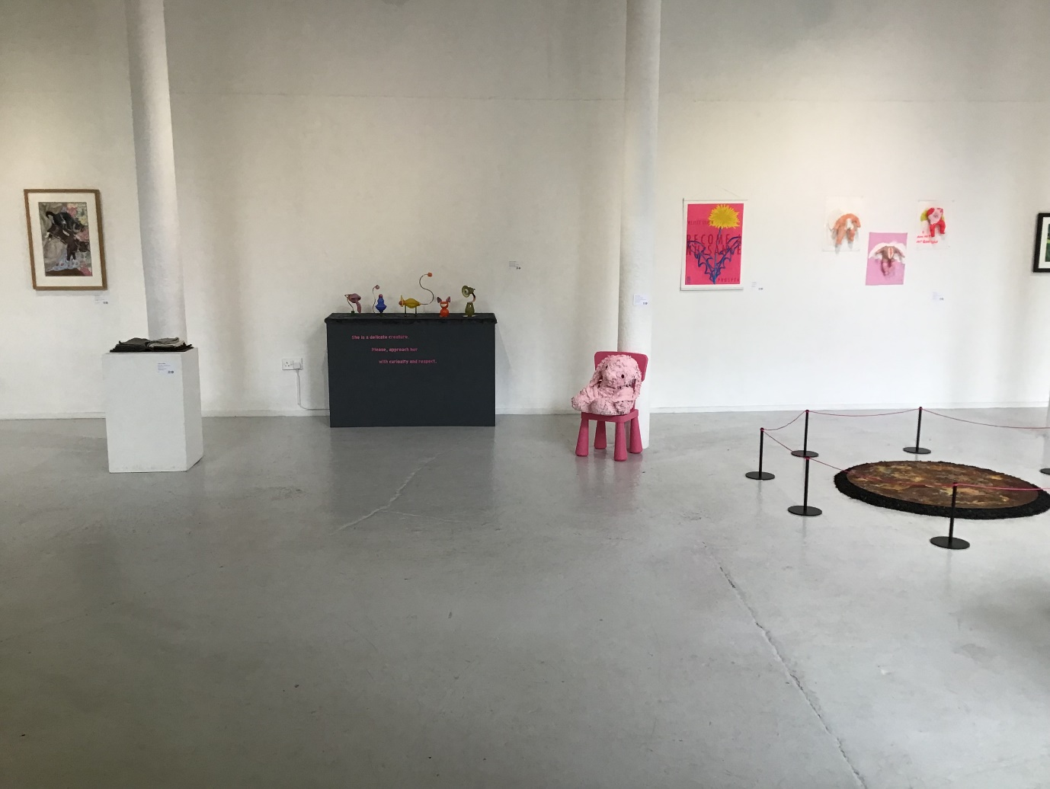

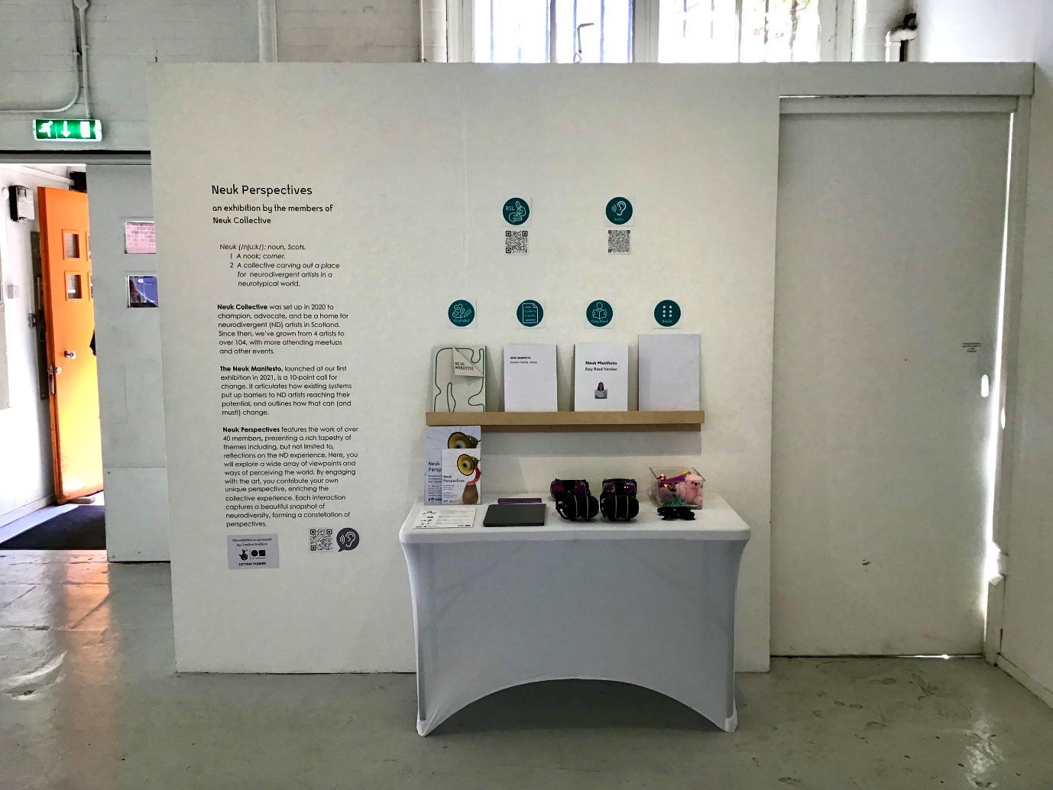
There is a sign telling you more about the exhibition. You can read it if you want to.
You can also read our manifesto – or take one home with you!

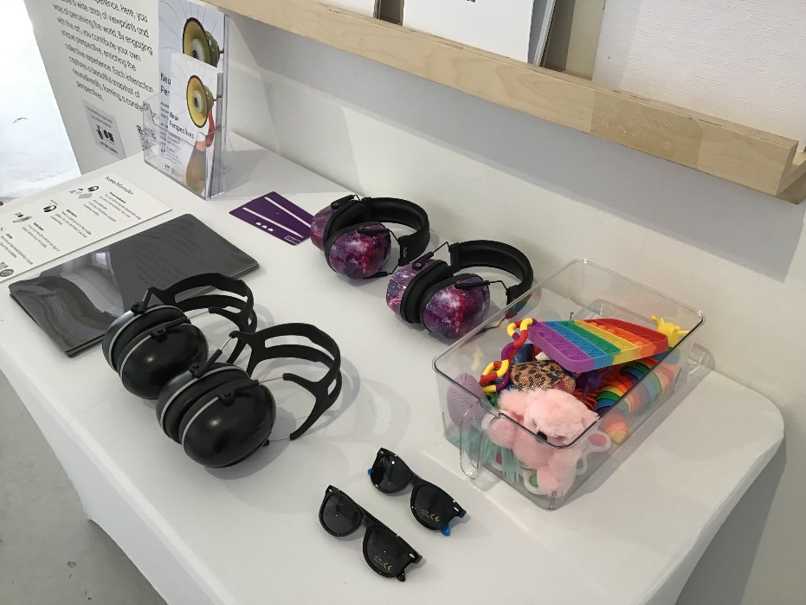
You can borrow any of the access equipment on the table. We have stim toys, eye shades, ear defenders, reading overlays and reading windows.

There are more ear defenders, eye shades, and stim toys in the Quiet Room.

You can look around at your own pace. But if you need any help you can ask the staff at the desk. They can also give you a folding chair if you need to sit down
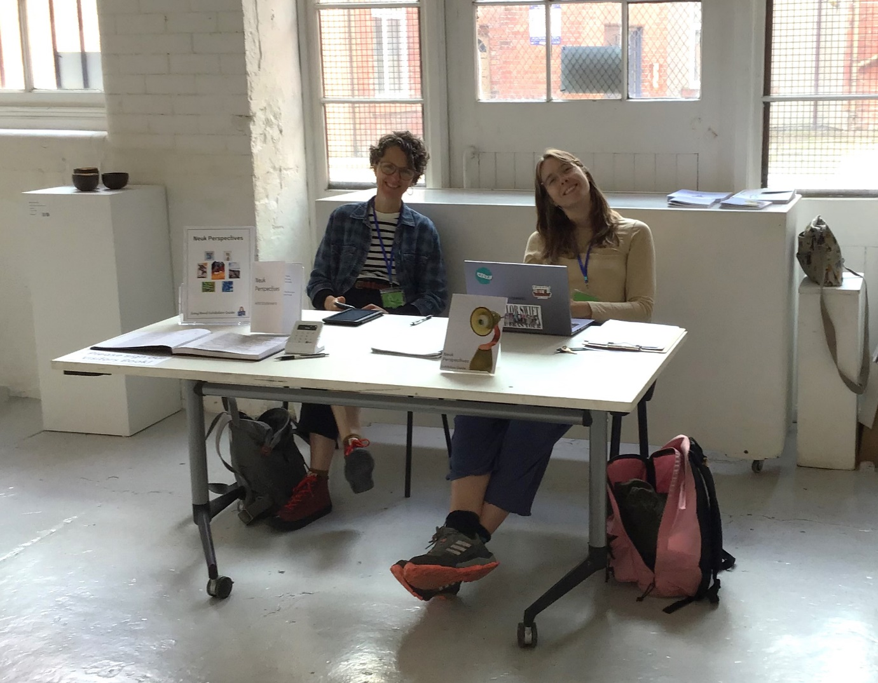
Two of the artworks in the front gallery play sound.
Decatstructed plays cat noises out loud. Interactive Light Box plays bird noises through headphones.
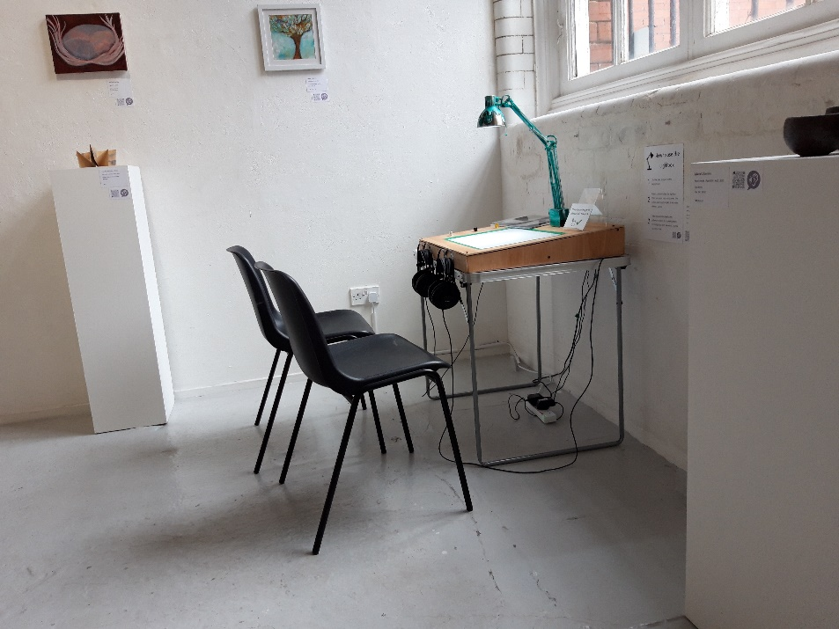
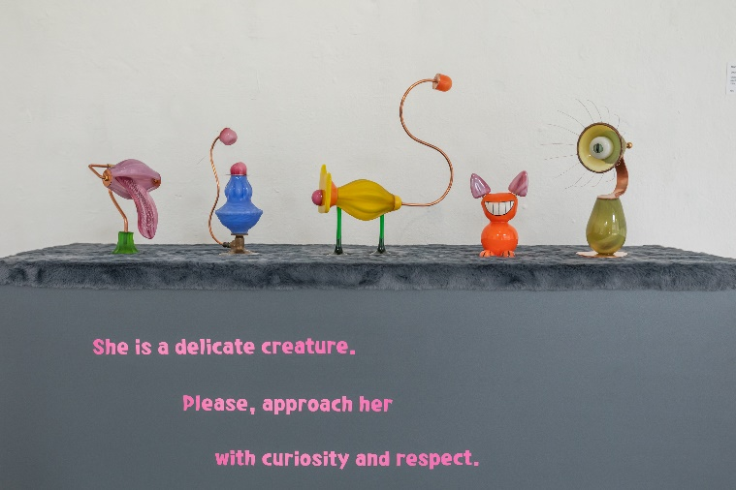
Interactive Light Box
Decatstructed

If you do not like the noise, you can borrow ear defenders, or ask the gallery staff and we can turn the noises off for you. We want to help!

The TVs in the rear gallery play sound through headphones. If you can hear it and it is bothering you, please ask the gallery staff or you can use the large remote controls to turn it down yourself.

Some of the artworks can be touched. They will have this special sign to show you that you can touch them.
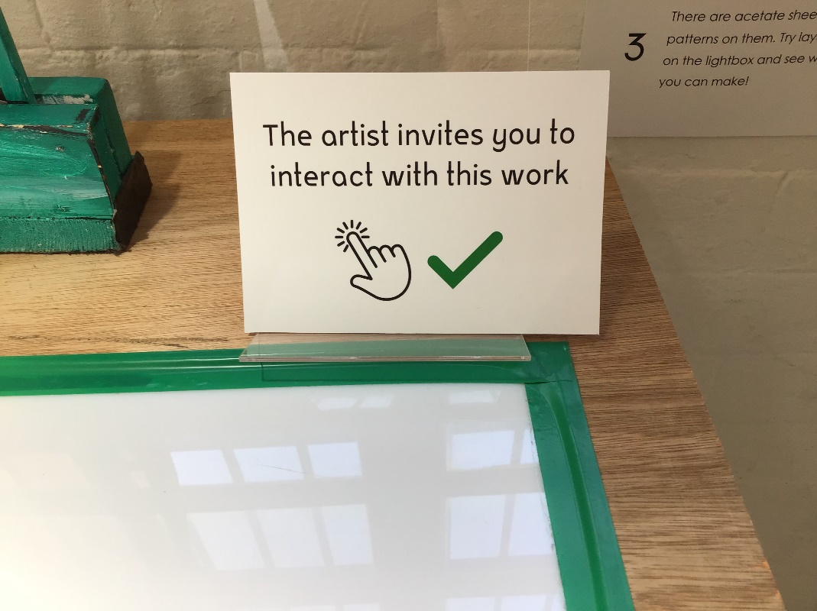

The exhibition is in 2 rooms. There is a door from the first room into a corridor. Turn right for the rest of the exhibition.
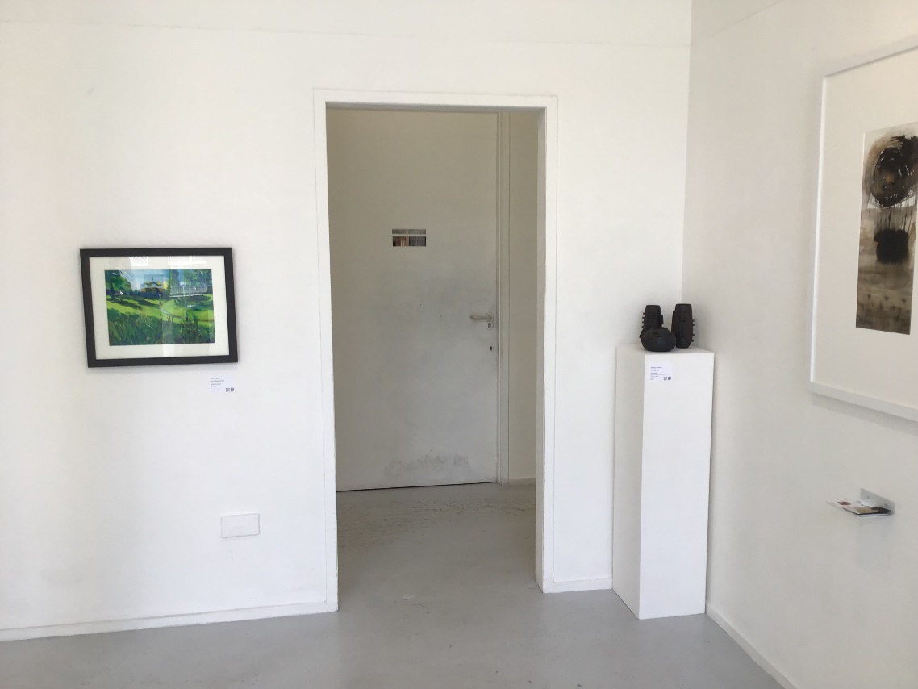

In the corridor there are two artworks, and a display about our crowdfunder.
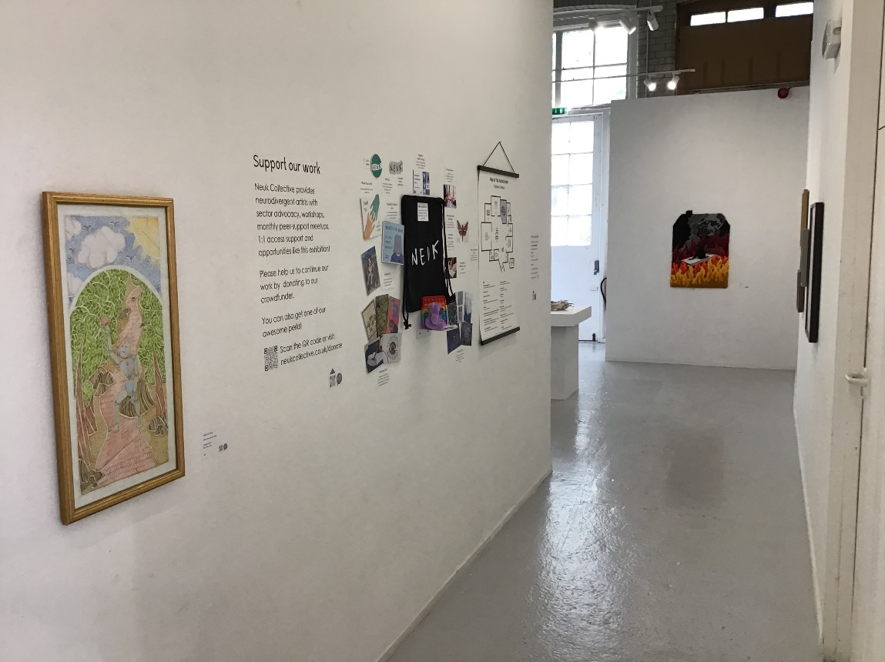

The smaller room has more artworks, 2 TV screens playing videos, and the Quiet Space.
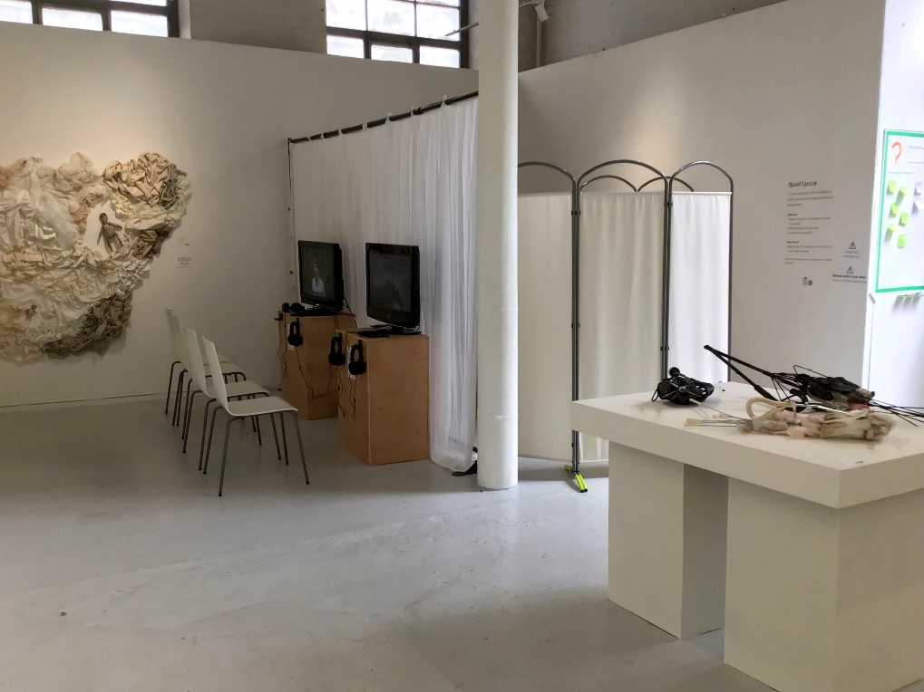

2 people at a time can watch the same video. The videos play on a loop. Each loop lasts around 20 minutes and it will alternate between captioned and non-captioned loops. If you want to change to a captioned or non-captioned loop, please ask the staff to help you.
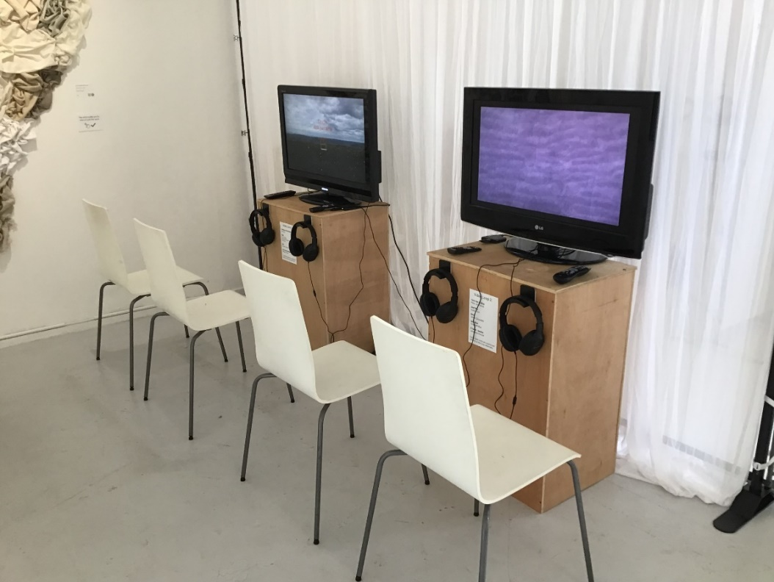
You can go into the quiet room if you would like to take time out or rest.
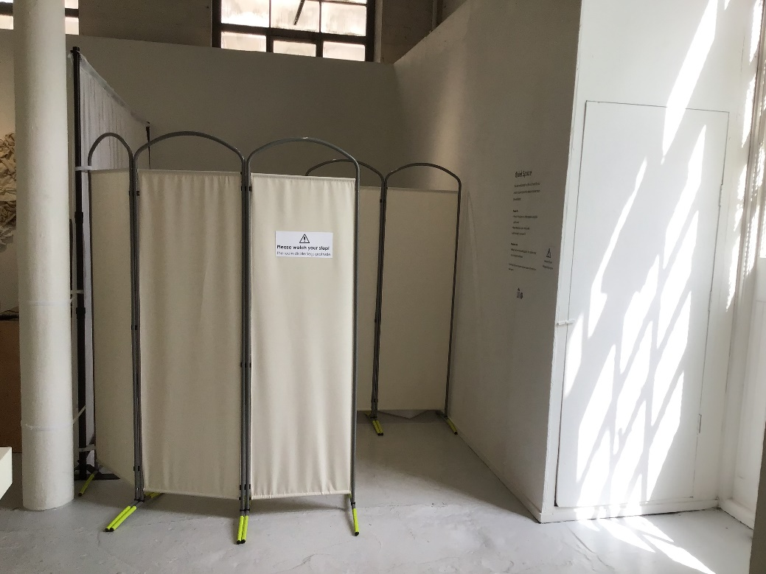

There are ear defenders, eye shades and stim toys in the Quiet Room. There is also an mp3 player with songs and poems by Neuk Collective artists, and books and zines.
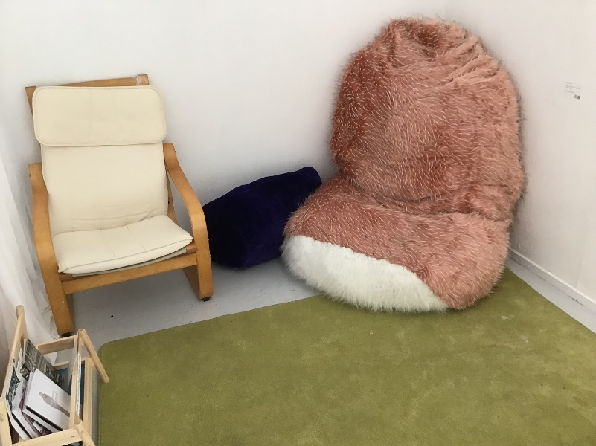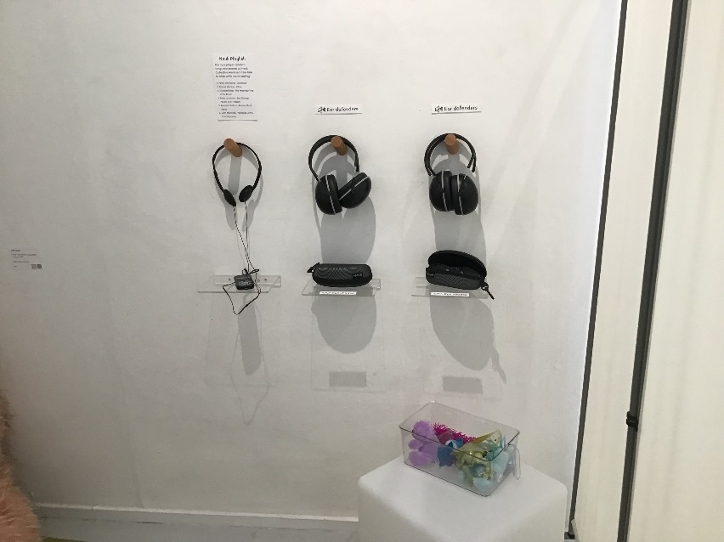

If you need the toilet, it is just off the larger gallery space. We have put up a sign to show you where to go.
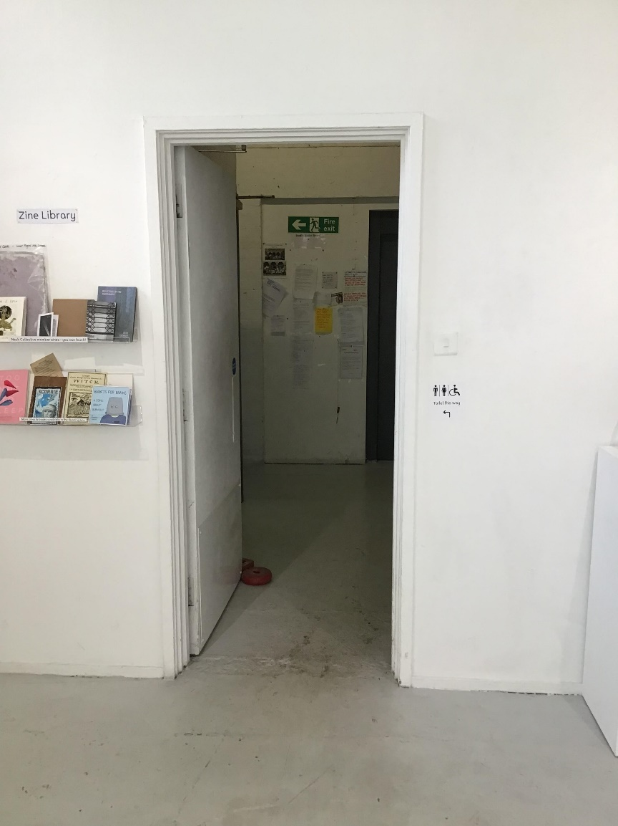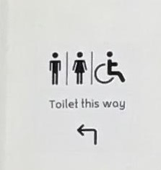

The toilet is a larger cubicle that might be suitable for some wheelchairs, but it does not have an emergency cord or handrails to transfer. If you need an accessible toilet, ask the staff to direct you to Stockbridge Library. This is just over the road from Patriothall.
Images of the toilet:
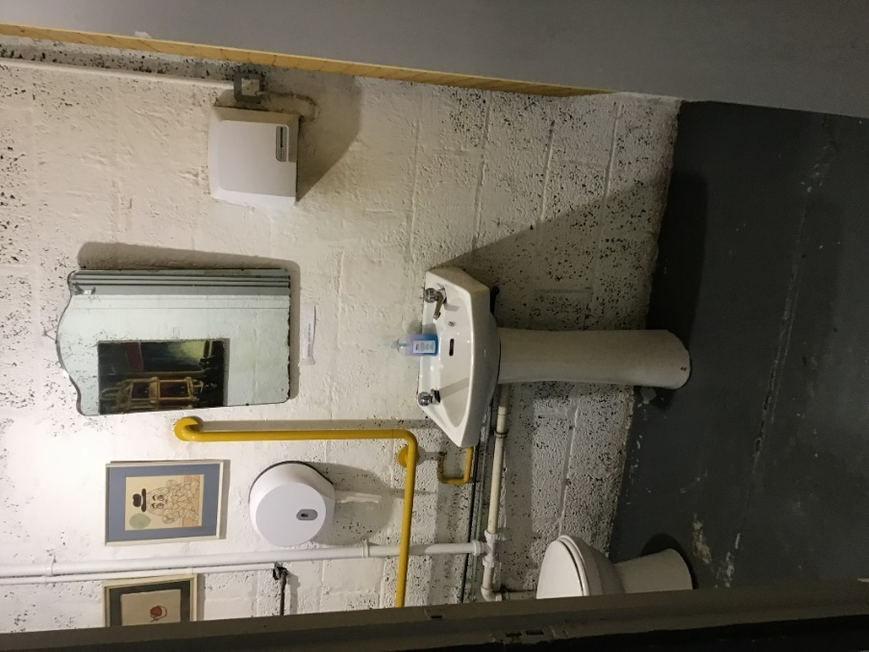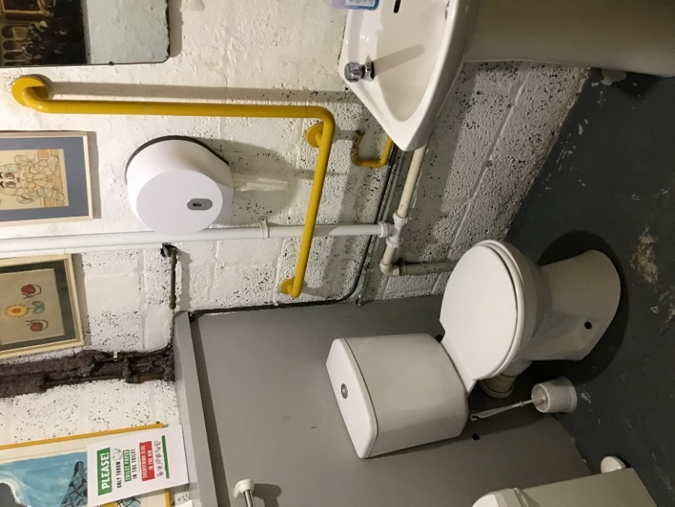
Don’t forget to leave us feedback! You can leave us a note on the feedback wall, or you can write in our visitors book:
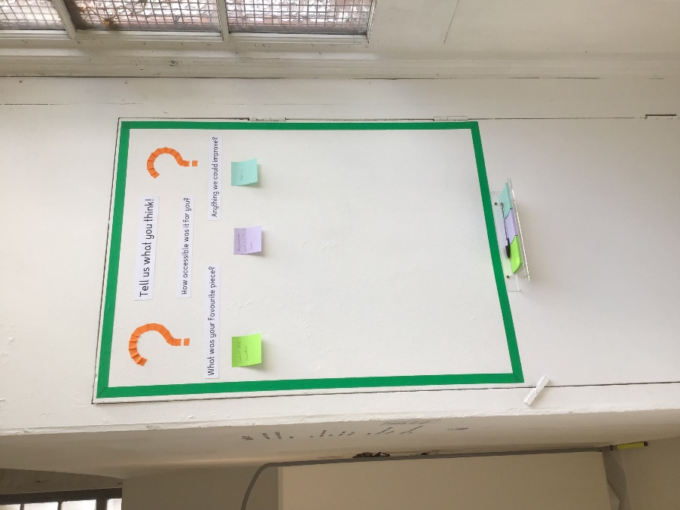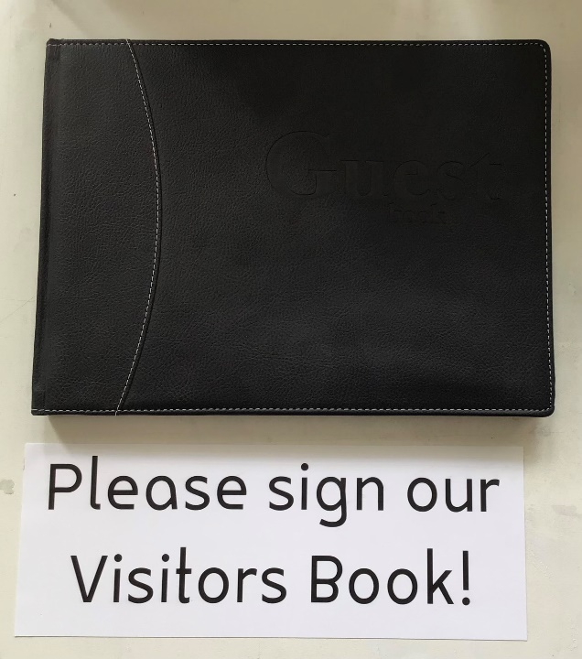

Thank you for visiting Neuk Perspectives!

