**Neuk Perspectives**

**Easy Read Exhibition Guide**

Introduction

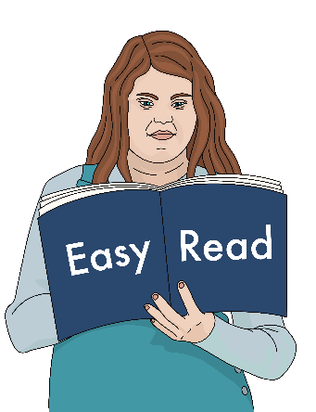

This is an Easy Read guide to the **Neuk Perspectives** **exhibition**. It tells you about the show.

We explain what **Neuk Perspectives** **exhibition** means on the next page.

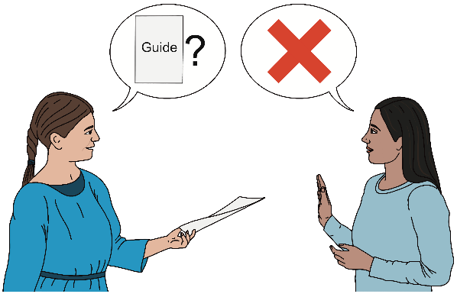

You do not need to read this guide if you do not want to.

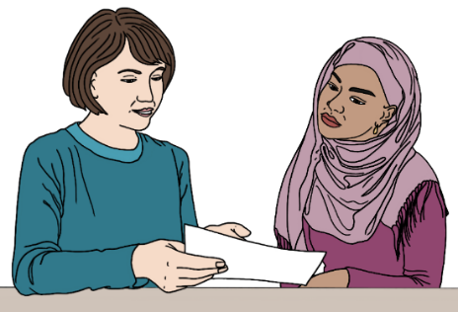

You can ask someone to help you read it.

What does **Neuk Perspectives exhibition** mean?

**­­**

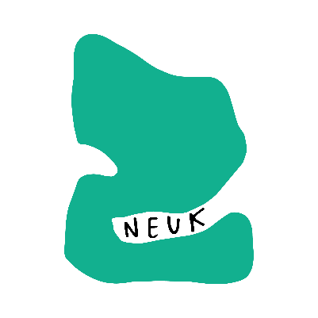

**Neuk** is the name of our group of artists. It also sounds a bit like “new”.

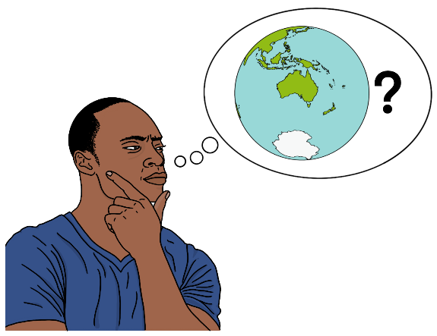

**Perspective** means the way people see and think about things.

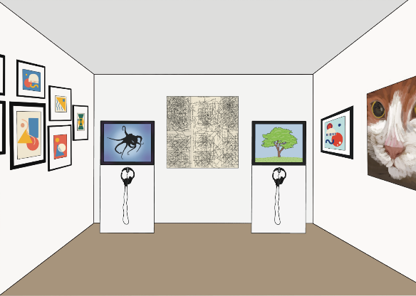

An **exhibition** is a show where you can see different art works.

Who made the art?

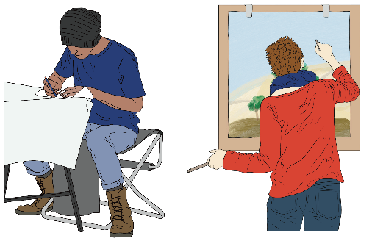  
All the art in the show was made by **neurodivergent** artists.

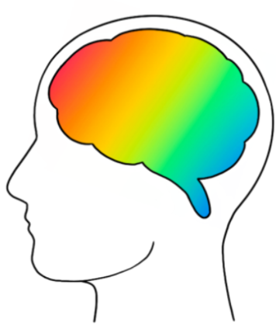  
**Neurodivergent** means having a brain that works differently from most people’s.

For example, lots of our artists are autistic, or dyslexic, or have ADHD.

What is the art about?

In our show you will see lots of different art and ideas.

Some art is about what it is like to be neurodivergent.

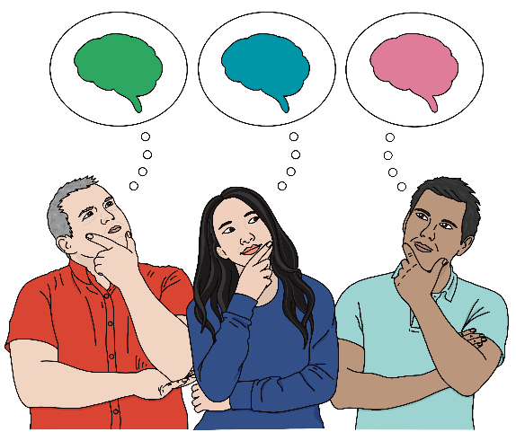

Neurodivergent people see the world in many different ways.

­

Being neurodivergent is complex. It is not all good or all bad.

Many artworks in the show look at different sides of being neurodivergent.

There is also art about other things the artists find interesting. For example, there is art about childhood, nature, animals and Scotland.

Your thoughts and feeling about the art are important too!

When you look at the art and think about it, you add your own perspective.

Enjoying the show

You can look around at your own pace.

You can touch the art that has this sign on it.

Please be gentle and careful.

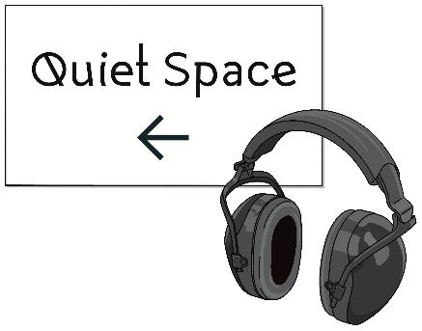

You can rest in the Quiet Space.

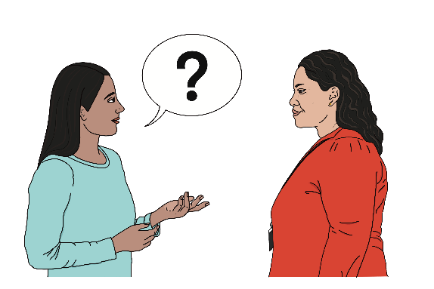

If you need any help, you can ask the gallery staff.

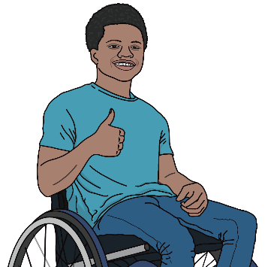

We hope you will enjoy the exhibition!